SoC2021 week 3 Sky Sunday Where to now?

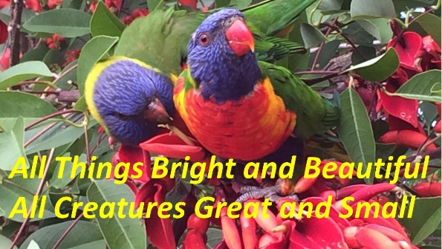
We don’t hear those words much these days, but what a beautiful simple message that teaches children about the connectedness between God and our world.
Thank God that more and more of the grown ups in faith communities around the world are embracing this, not just in this annual Season of Creation but throughout our faith journeys.

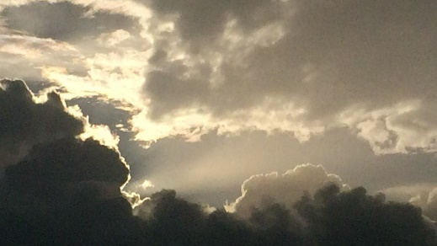
Thanks especially to Pitt st for embracing this idea of caring for the planet as adding deep meaning to our faith journey. There is a growing inter-faith movement that also embraces this idea, which I will come back to.

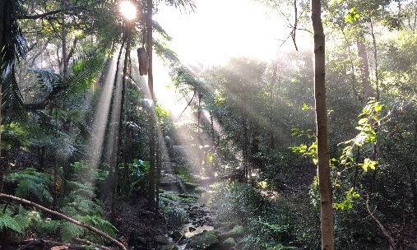

Two weeks ago, Jo discussed ‘helpful’ and ‘unhelpful’ models and metaphors of the earth. One unhelpful model is to see the earth as a supermarket – as a collection of objects from which we can pick and use up at will. Unfortunately this model is still influential in some Christian thinking.

The alternative model, which really chimed with me, was to see the Earth as a communion of subjects. We saw and heard this beautifully expressed in last Sunday’s anthology of individual experiences with nature compiled by our friends at Glenbrook Uniting.

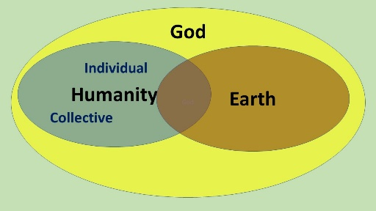
You may remember Jo suggested an exercise where we might reflect on how the three elements of creation (God, humanity, and the Earth) inter-relate… perhaps using different coloured sheets to represent them? Those Glenbrook stories last week were another powerful representation of communion with God and the Earth at an individual human level.

I would like to suggest another perspective on communion at the collective human level.
Its what we do as Pitt st every Sunday but also when we share in something like our action at 11am on March 11th this year

We bagpiped down Pitt st with our banners and leaflets. The Ecopella choir entertained the passers by and Jo and Penny joined in their first Pitt st activity. It was a lot of fun but also very moving as a form of communion

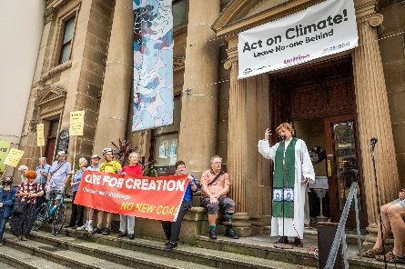
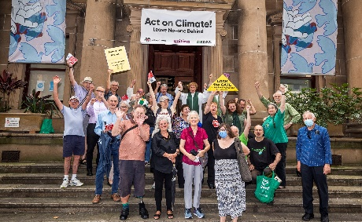
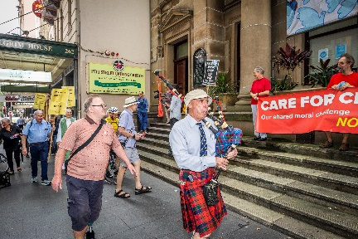

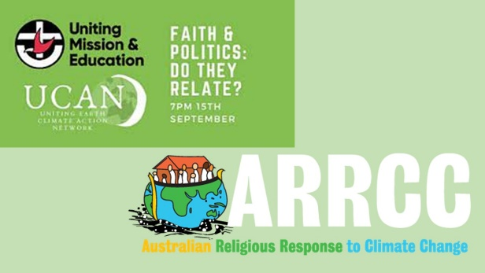
136 other faith communities around Australia were also having fun at 11am, ringing bells, making noise. Many other Uniting Churches plus Buddhists, Jews, Catholics, muslims, Quakers, you name it. So our communion was much wider, because of our networking both through Synod and also ARRCC – the Australian Religious Response to Climate Change.
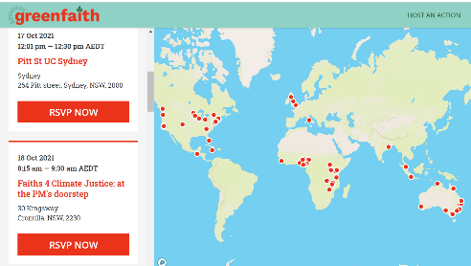
And our communion was wider still as ARRCC links us to the global multi-faith group Greenfaith. Around the world, hundreds more communities of faith are taking their spiritual perspective on caring for Creation into the streets and into the faces of political leaders.

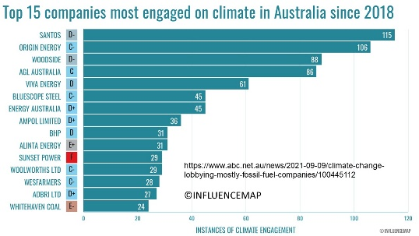
But lets look at who else is talking to the leaders – this graph shows the hundreds of Corporate engagements on climate with government in the last three years. It adds up to a small but powerful communion of coal and gas corporations with vested interests to protect.

The point of the report this comes from wasn’t to say “shock horror, fossil fuel sector is constantly lobbying government”. The point was that many many other corporates are pro-climate action but just don’t engage so assertively. Lets face it many of us are a bit like that… of course we think creation is important, but what difference can we make?
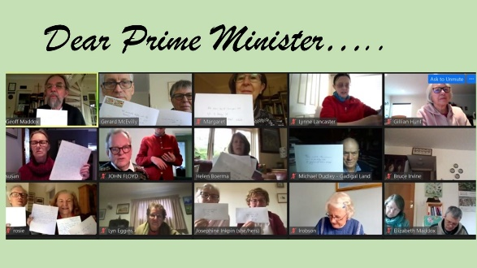
Thankfully as individuals and as a communion there is a lot we can do, from checking who our super is invested with to handwriting personal letters to the PM like we did recently – some of over 600 he received this week.
We might be able to follow up in person at the PMs office next month, IF covid allows. …
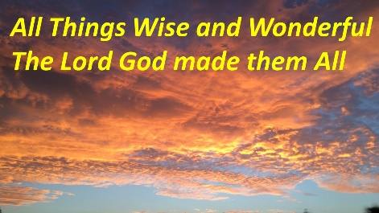

Two weeks before he goes to the COP talks in Glasgow that set the stage for our grandchildrens’ future.

Who knows, with our prompting, our leaders may turn out to be wise and wonderful after all.

